SCHOOL OF COMPUTER SCIENCE AND ARTIFICIAL INTELLIGENCE |  |  |  |  | DEPARTMENT OF COMPUTER SCIENCE ENGINEERING
ProgramName:B. Tech |  |  |  | Assignment Type: Lab |  |  | AcademicYear:2025-2026
CourseCoordinatorName |  |  |  | Venkataramana Veeramsetty
Instructor(s)Name |  |  |  | Dr. V. Venkataramana (Co-ordinator)  Dr. T. Sampath Kumar  Dr. Pramoda Patro  Dr. Brij Kishor Tiwari  Dr.J.Ravichander  Dr. Mohammand Ali Shaik  Dr. Anirodh Kumar  Mr. S.Naresh Kumar  Dr. RAJESH VELPULA  Mr. Kundhan Kumar  Ms. Ch.Rajitha  Mr. M Prakash  Mr. B.Raju  Intern 1 (Dharma teja)  Intern 2 (Sai Prasad)  Intern 3 (Sowmya)  NS_2 ( Mounika)
CourseCode |  |  | 24CS002PC215 | CourseTitle |  | AI Assisted Coding
Year/Sem |  |  | II/I | Regulation |  | R24
Date and Day  of Assignment |  |  | Week4 - Wednesday | Time(s)
Duration |  |  | 2 Hours | Applicableto  Batches
AssignmentNumber:9.3(Present assignment number)/24(Total number of assignments)
 | Q.No. | Question |  |  |  |  |  | ExpectedTime  to complete
 | 1 | Lab 8: Documentation Generation: Automatic documentation and code comments  Lab Objectives:  - To understand the importance of documentation and code comments in software development.  - To explore how AI-assisted coding tools can generate meaningful documentation and inline comments.  - To practice generating function-level and module-level docstrings automatically.  - To evaluate the quality, accuracy, and limitations of AI-generated documentation.  - To develop a small automated tool for documentation generation in Python..  Lab Outcomes (LOs):  After completing this lab, students will be able to:  - Apply AI-assisted coding tools to generate docstrings and inline comments for Python code.  - Critically analyze AI-generated documentation for correctness, completeness, and readability.  - Create structured documentation (function-level, module-level) following standard formats.  - Design and implement a mini documentation generator tool to automate code commenting and docstring creation.  Task Description#1 Basic Docstring Generation  - Write python function to return sum of even and odd numbers in the given list.  - Incorporate manual docstring in code with Google Style  - Use an AI-assisted tool (e.g., Copilot, Cursor AI) to generate a docstring describing the function.  - Compare the AI-generated docstring with your manually written one.  USER CODE:  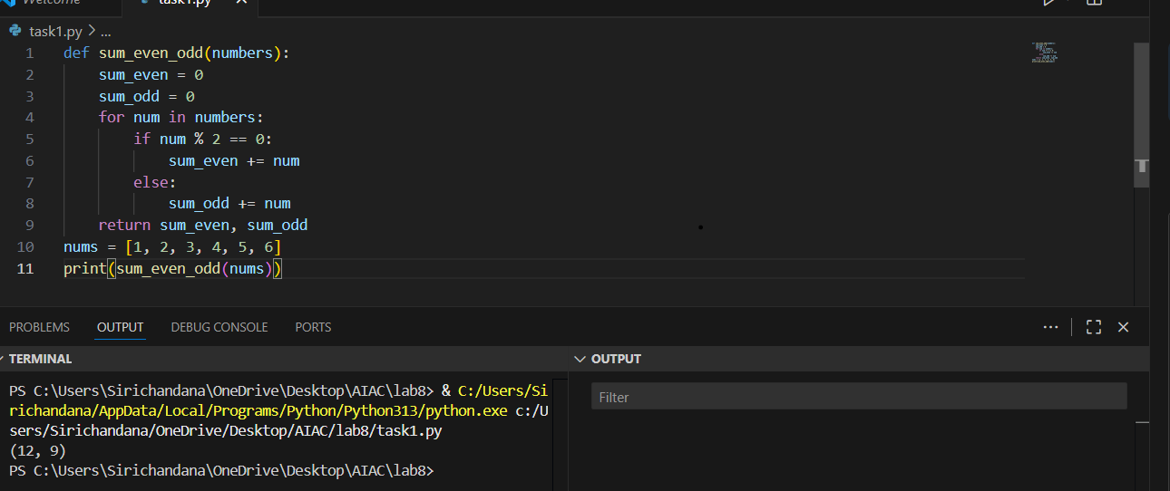  USER DOC STRING:  def sum_even_odd(numbers):  """  This module provides a function to calculate the sum of even and odd numbers in a given list.  Args: numbers (list of int): List of integers to process.  Returns:  sum_even_odd(numbers): Returns a tuple containing the sum of even and odd  """  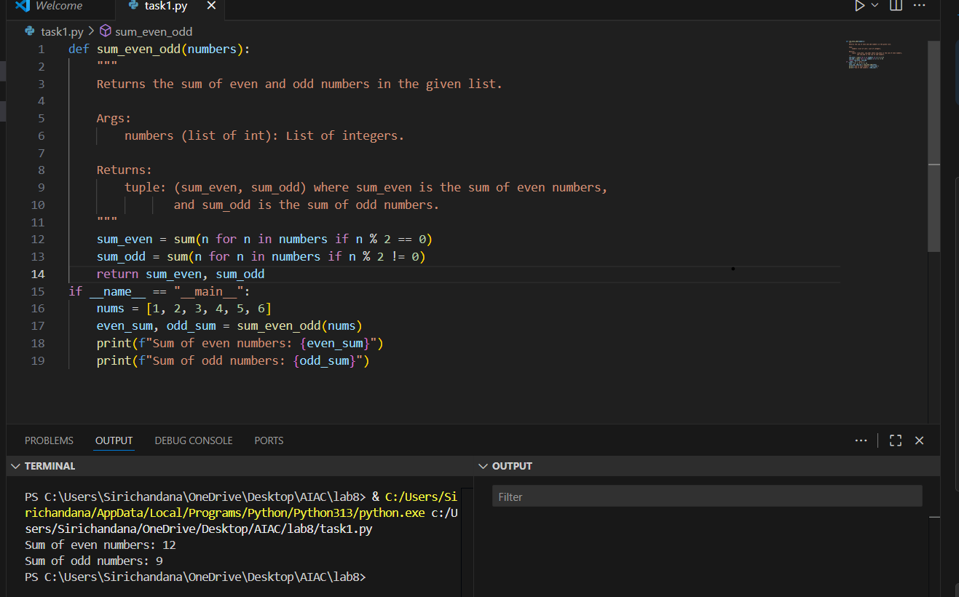  # Comparison:  # Comparison of the code and the docstring provided:  # 1. The code defines a function sum_even_odd(numbers) that takes a list of integers and returns a tuple (sum_even, sum_odd).  # - sum_even: sum of all even numbers in the list.  # - sum_odd: sum of all odd numbers in the list.  # 2. The code includes a main block that demonstrates usage:  # - It creates a list nums = [1, 2, 3, 4, 5, 6]  # - Calls the function and prints the results.  # 3. The docstring at the end describes the module:  # - States that the module provides a function to calculate the sum of even and odd numbers.  # - Lists the function and its purpose.  # Conclusion:  # - The code and the docstring are consistent.  # - Both describe and implement a function that returns the sum of even and odd numbers from a list.  # - The docstring accurately reflects the functionality provided by the code.  Expected Outcome#1: Students understand how AI can produce function-level documentation.  Task Description#2 Automatic Inline Comments  - Write python program for sru_student class with attributes like name, roll no., hostel_status and fee_update method and display_details method.  - Write comments manually for each line/code block  - Ask an AI tool to add inline comments explaining each line/step.  - Compare the AI-generated comments with your manually written one.  USER CODE:  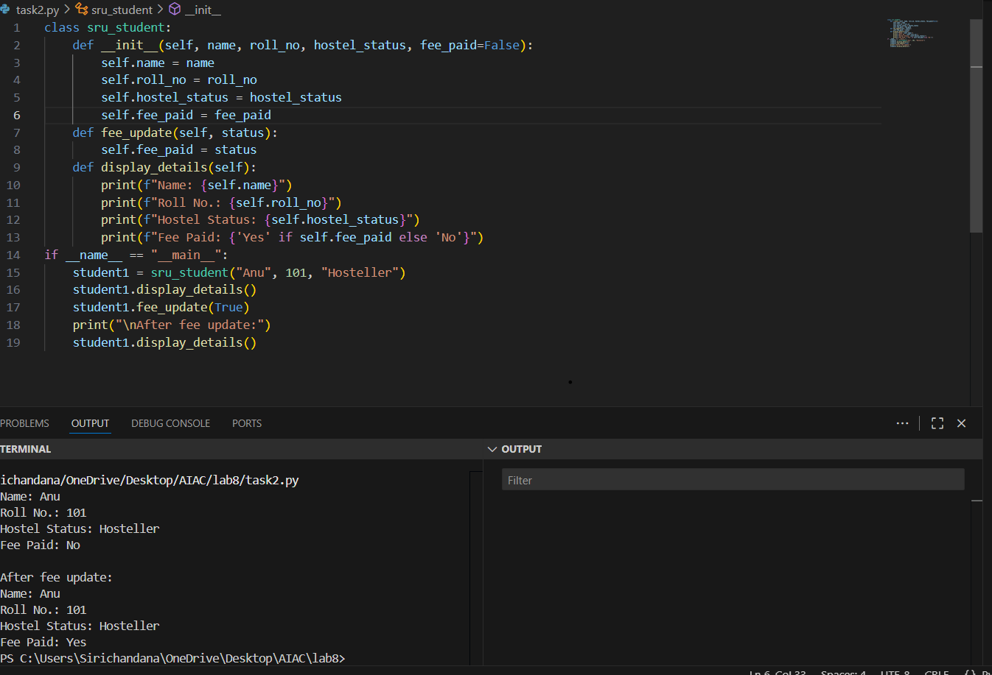  USER DOC STRING:  def fee_update(self, status):  """  Updates the fee payment status.  Args:  status (bool): True if fee is paid, False otherwise.  """  self.fee_paid = status  def display_details(self):  """  Displays the student's details.  """  print(f"Name: {self.name}")  print(f"Roll No.: {self.roll_no}")  print(f"Hostel Status: {self.hostel_status}")  print(f"Fee Paid: {'Yes' if self.fee_paid else 'No'}")  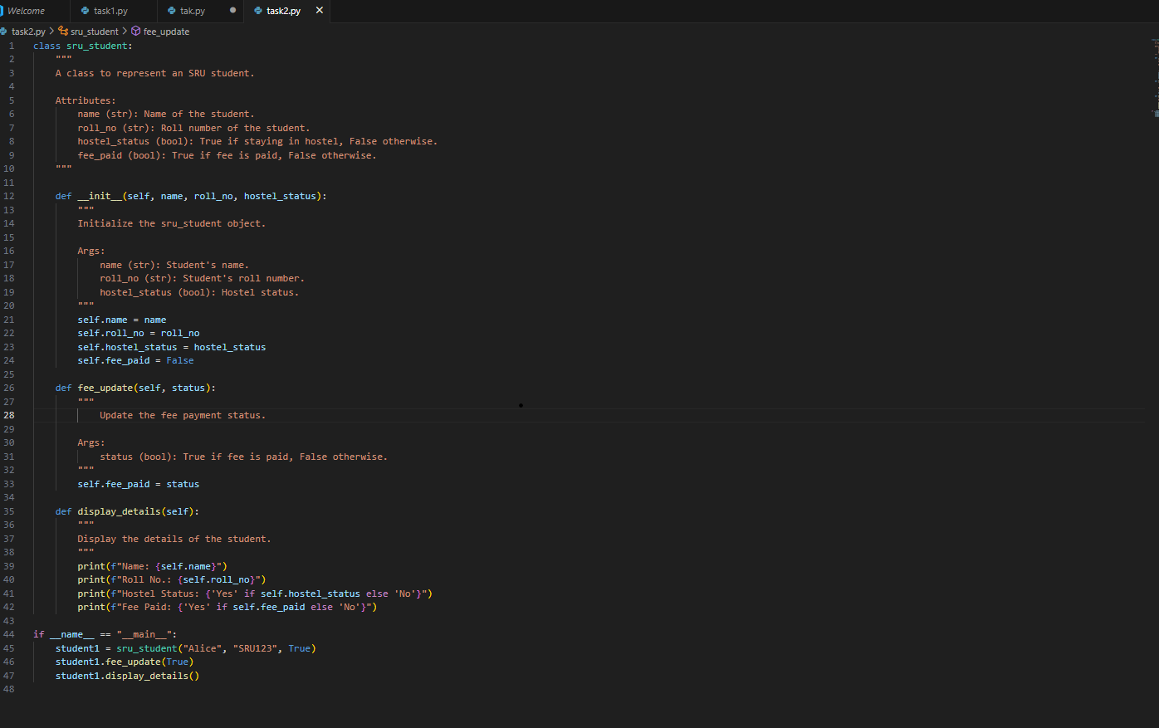  Expected Output#2: Students critically analyze AI-generated code comments.  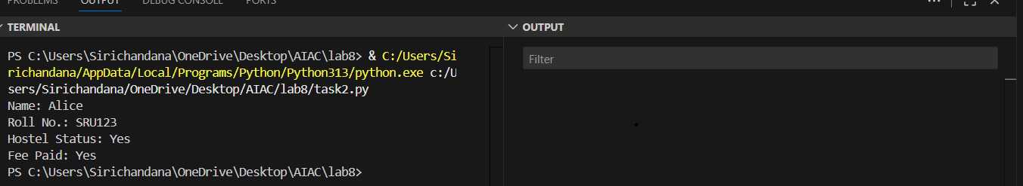  COMPARISION:  # First Implementation:  """  A class to represent an SRU student.  Attributes:  name (str): Name of the student.  roll_no (str): Roll number of the student.  hostel_status (bool): True if staying in hostel, False otherwise.  fee_paid (bool): True if fee is paid, False otherwise.  """  # Second Implementation:  # No class-level docstring is present.  # __init__ method docstrings:  # First Implementation:  """  Initialize the sru_student object.  Args:  name (str): Student's name.  roll_no (str): Student's roll number.  hostel_status (bool): Hostel status.  """  # Second Implementation:  # No docstring for __init__ method.  # fee_update method docstrings:  # First Implementation:  """  Update the fee payment status.  Args:  status (bool): True if fee is paid, False otherwise.  """  # Second Implementation:  """  Updates the fee payment status.  Args:  status (bool): True if fee is paid, False otherwise.  """  # display_details method docstrings:  # First Implementation:  """  Display the details of the student.  """  # Second Implementation:  """  Displays the student's details.  """  # CONCLUSION:  # - The first implementation provides a class-level docstring and docstrings for __init__, fee_update, and display_details methods.  # - The second implementation only provides docstrings for fee_update and display_details methods, and omits the class-level and __init__ docstrings.  # - The first implementation's docstrings are more descriptive and follow a structured format.  Task Description#3  - Write a Python script with 3–4 functions (e.g., calculator: add, subtract, multiply, divide).  - Incorporate manual docstring in code with NumPy Style  - Use AI assistance to generate a module-level docstring + individual function docstrings.  - Compare the AI-generated docstring with your manually written one.  Expected Output#3: Students learn structured documentation for multi-function scripts  USER CODE:  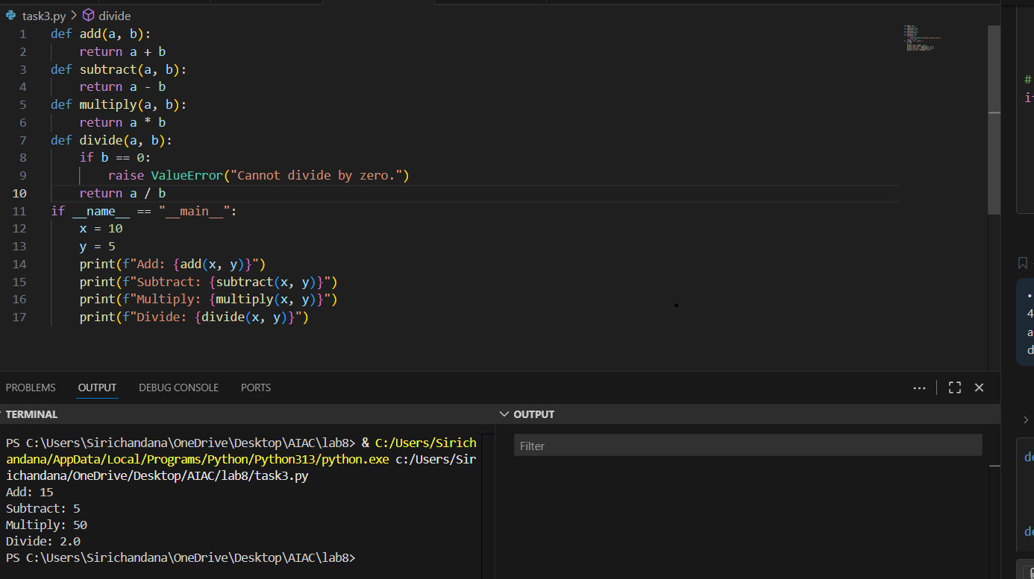  USER DOC STRING:  """  This script provides basic calculator functions: add, subtract, multiply, and divide.  Functions:  add(a, b): Returns the sum of a and b.  subtract(a, b): Returns the difference of a and b.  multiply(a, b): Returns the product of a and b.  divide(a, b): Returns the division of a by b. Raises ValueError if b is zero.  """  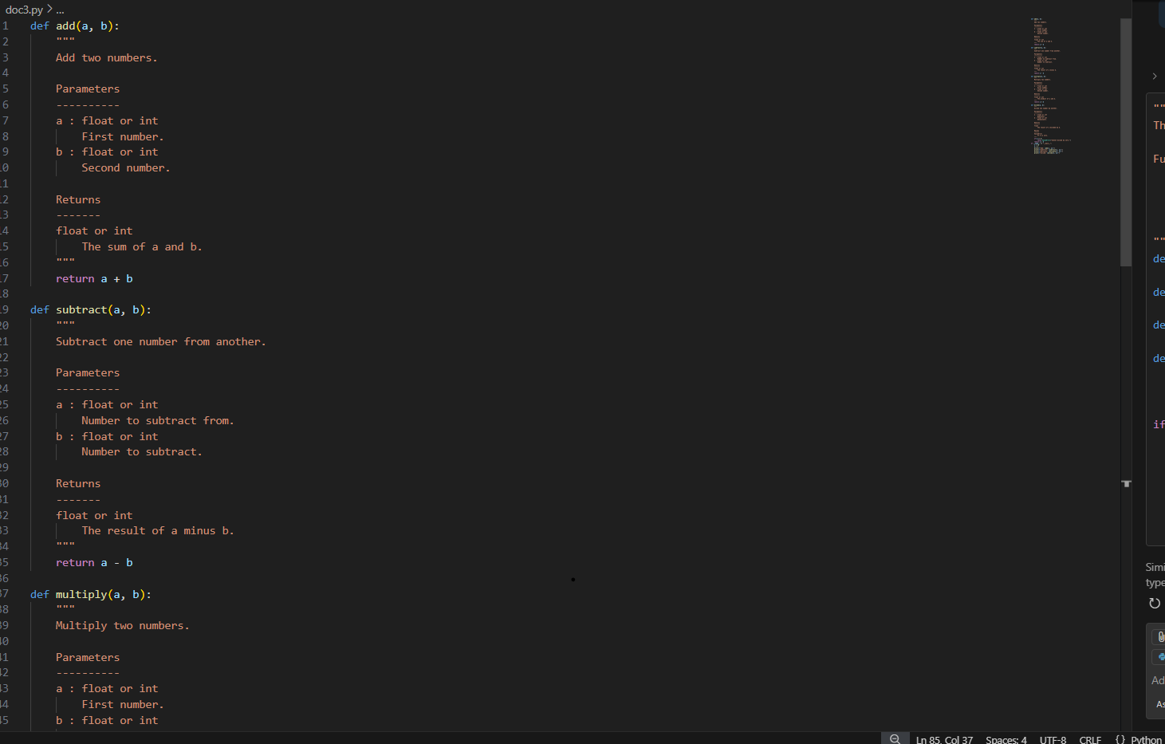  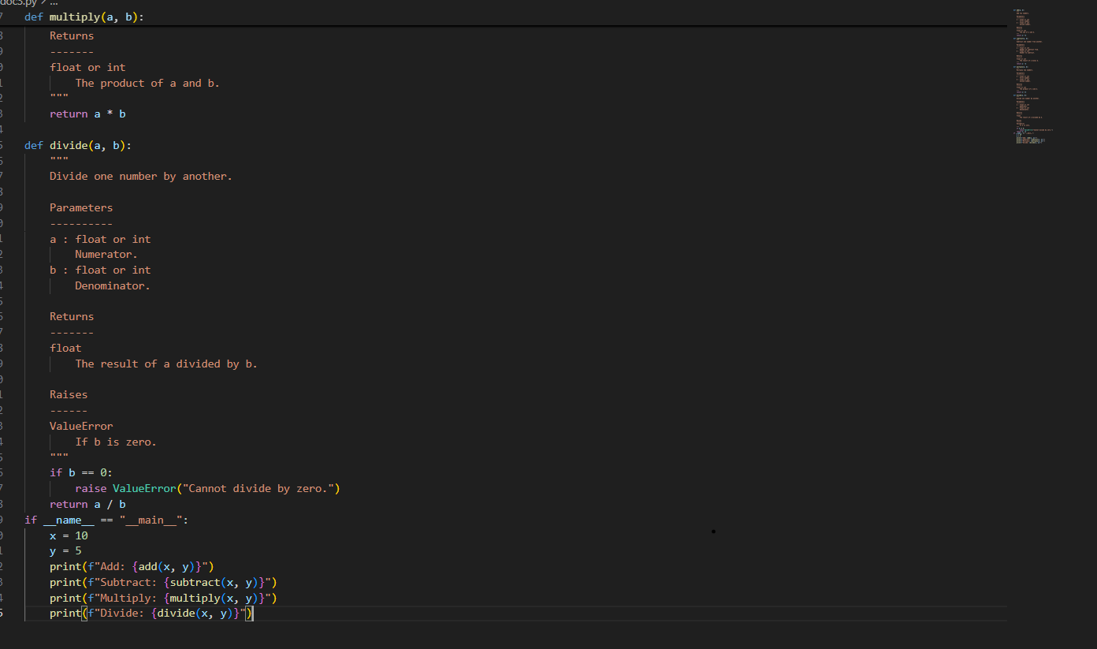  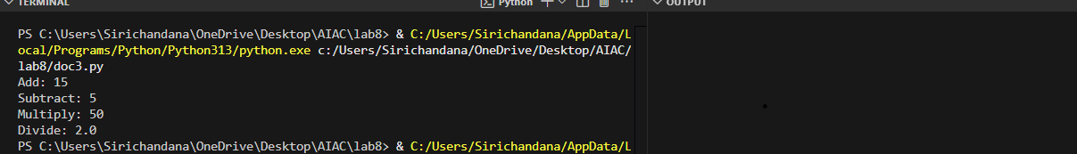  COMPARISION:  """  This script provides basic calculator functions: add, subtract, multiply, and divide.  Functions:  add(a, b): Returns the sum of a and b.  subtract(a, b): Returns the difference of a and b.  multiply(a, b): Returns the product of a and b.  divide(a, b): Returns the division of a by b. Raises ValueError if b is zero.  """  Push documentation whole workspace as .md file in GitHub Repository  Note: Report should be submitted a word document for all tasks in a single document with prompts, comments & code explanation, and output and if required, screenshots |  |  |  |  |  | Week4 - Wednesday

